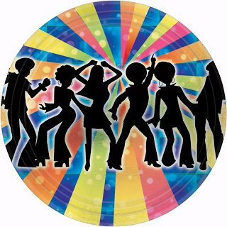 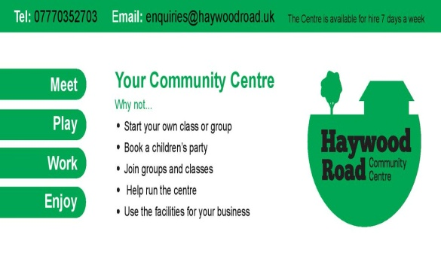

**FREE FAMILY DISCO**

**SATURDAY JULY 1ST 6PM TO 9PM**

**Cash bar**



**Part of the Porchester Festival 2017**